# **Internet Alert Box Web Part Documentation**

This document describes how to place alert boxes, which are commonly used to communicate important notices to visitors of the Florida Department of Revenue Internet site, floridarevenue.com

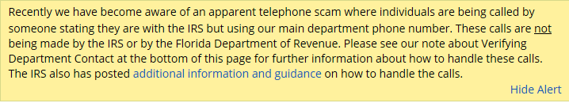

Figure - An example of the Internet alert box

There are three variants of the alert box that can be used:

* An alert box that can be displayed on one or more of the Department of Revenue’s top-levels landing pages (ie. Homepage, General Tax, Property Tax Oversight, Child Support)
* An alert box that can display a single notice on a specific web page other than a landing page (ex. FDOR Contact Us Page)
* An alert box that can display more than one notice on a specific web page, other than a landing page (ex. Tax and Interest Rates page)

**Note**: “Legacy” Internet pages, those with /dor/ in the URL, have their own variant of alert boxes that will not be covered in this document. The legacy alert boxes must be manually placed by the ISP SharePoint team, whereas the alert boxes on our SharePoint Internet pages can be deployed by anyone with permissions to edit pages.

## Deploying the Landing Page Alert Box

Before deploying a landing page alert box, you will need to know the following information, which is usually provided by the Department of Revenue’s Communications Office:

* What is the text of the message that should be displayed?
* What word, if any, should begin the message in bold type? (Choices include Important, Attention, Critical, Warning or Normal/None)
* What color background should the alert box use? (Yellow is used by default, but other choices include red, blue and green)
* When should the message begin displaying (start date) and when should the message expire (end date)? (If an indefinite end date is desired, set the message to expire several months or more in the future.)
* On which top-level pages should the message be displayed? (FDOR Homepage, GTA Homepage, CSP Homepage and PTO Homepage)

To add a new message or edit an existing message:

* Visit <https://dorspint.fdor.dor.state.fl.us> (or the equivalent site in DEV or QAS, if a test display is needed) in your web browser
* You should see the SharePoint user options in the upper-right of the browser screen. Click on the “cog” icon () to display a drop-down menu.
* If you have the necessary permission to view site contents and edit pages, the drop-down menu should look like this:

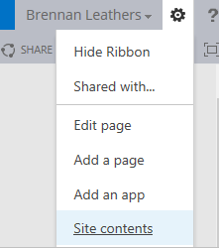

* Click on the “Site Contents” link, then click on the SharePoint list named “Alerts”.

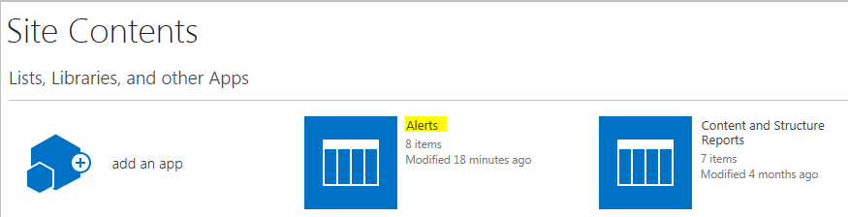

After clicking on the Alerts list icon, you will see an alert management screen.

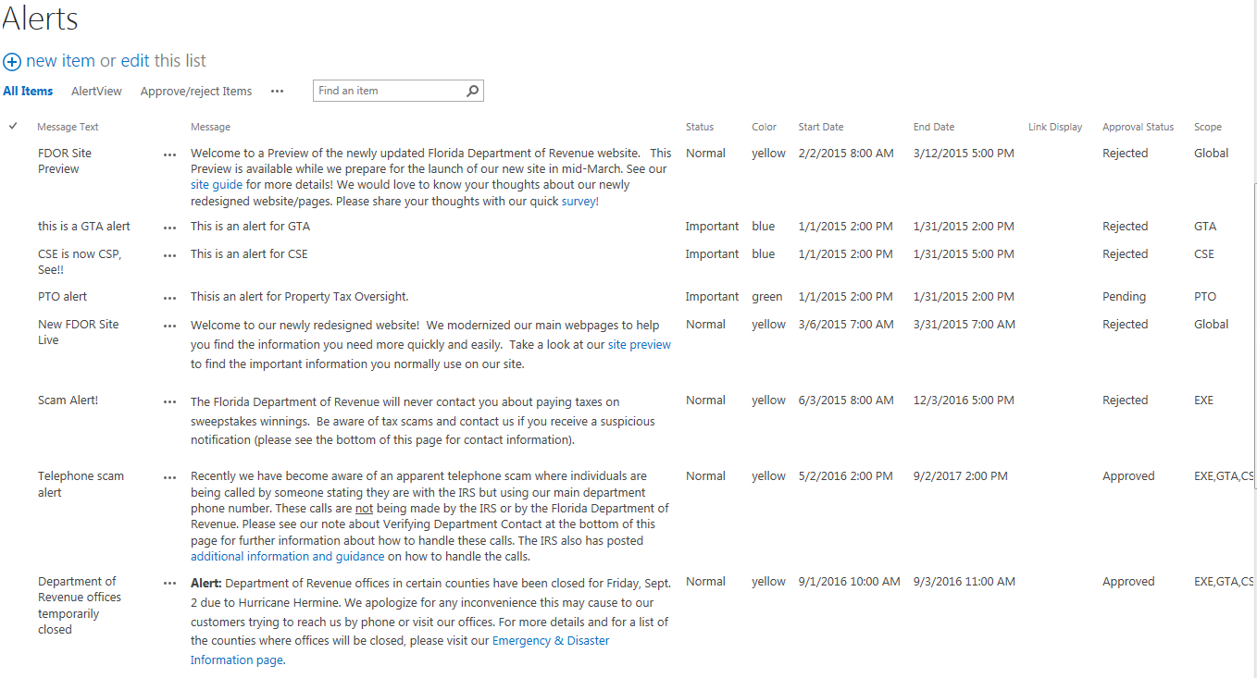

To add a new alert, click on the “New Item” link.

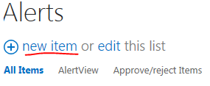

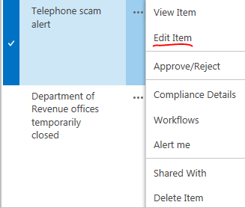To edit an existing alert, find the alert you want to edit, then click on the SharePoint ellipsis () to display a pop-up menu. From there, click the “Edit Item” link.

Both the “New Item” and “Edit Item” screens show the same fields: Status, Message Text, Color, Start Date, End Date, Link, Link Display, Message and Scope. We will go over each field in detail.

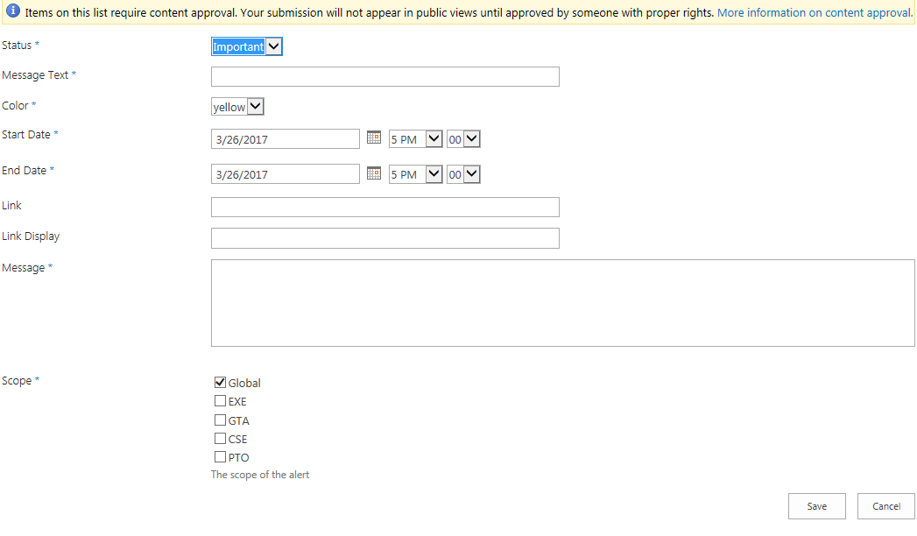

* 

The Status field is required and can be used to prepend the alert message with a bolded word and a colon. The default value is “**Important**:”; other values include Attention, Critical, Warning and Normal. If Normal is selected, no word will be prepended to the alert message.

* 

The Message Text field is required and is used to quickly identify the title or summary of an alert message. Text entered into this field is only shown on the “Alerts” administration page, and is not included in the alert box displayed to website visitors.

*   
  The Color field is required and determines the background color of the alert message. The default value is Yellow; other choices include Red, Green and Blue.
*   
  The Start Date field is also required and is used to specify at what date and time the message should begin displaying. The date and times chosen are related to Tallahassee, Fla., time, in the Eastern U.S. time zone.   
  -- If you want to begin displaying the alert immediately, choose a date and/or time that is in the past.  
  -- If you want to schedule an alert to display in the future, choose a date and/or time in the future. Once the alert is approved, SharePoint will wait until the chosen time arrives and then begin displaying the alert.
*   
  The End Date field is required and is used to specify at what date and time the alert box message should stop displaying. Again, the date and time is applicable to Eastern U.S. time. It is important to check with the Department of Revenue Communications Office and Revenue programs’ SharePoint approvers--if the alert message is applicable to a specific Revenue program—for the appropriate end time.  
  -- Important Considerations: if the alert message concerns a Department of Revenue office closure, it is important not to have the closure alert displaying after the office has re-opened. For this reason, the Communications Office may wish to modify the text of the alert, as well as the end date, on a daily basis as more details become known.  
  -- If the alert message is of an indefinite nature, such as a scam alert, consider setting the end date several months into the future, unless otherwise specified by the Communications Office. If a previously-expired alert message is being re-activated (such as a seasonal alert), please ensure the End Date is in the future. For example, the End Date’s year may need to be modified before the alert will display.
* 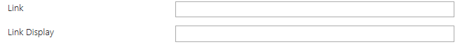  
  The Link and Link Display fields, which are optional, can be used to display an Internet link adjacent to the alert message. This link is an alternative to placing an HTML link in the message text itself (to be discussed later in this document).
* Below is an example of a link set up using a link specified in the Link and Link Display fields.

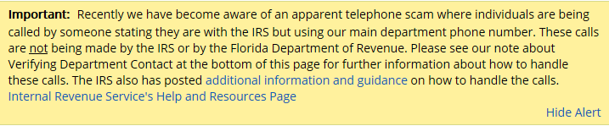

Below is what we input into the fields to display a link at the end of the alert message.



* The Message field is required and contains the text that will be displayed to website visitors in the alert box.



Once you click the mouse into the Message field’s text box, the SharePoint ribbon will change to show a formatting toolbar.



The formatting toolbar can be used to change the font weight and size, insert bulleted lists or indenting, and choose the paragraph alignment. It’s also possible to copy message text from Microsoft Word and paste it directly into the message field, with any formatting applied in Word carrying over to the SharePoint editing form.

* Users familiar with HTML code may wish to use the Edit Source icon in the SharePoint toolbar, for more precise placement of links.
* Users who don’t know HTML can still create a link using the SharePoint formatting toolbar. Here are the steps:  
  1) Highlight the text to be linked by clicking and dragging the mouse over the desired link text.   
  2) In the SharePoint toolbar, click on the “Insert” tab. Then click on the “Link” icon and in the menu that pops up, select “From Address”.

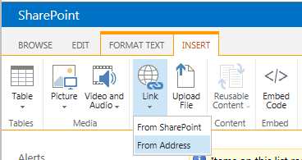

3) Type or paste the link URL into the “Address” field and modify the link text, if desired.

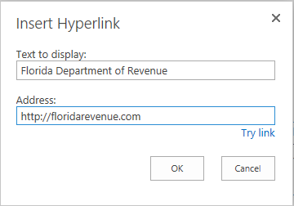

* 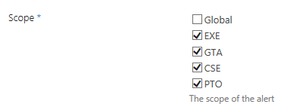

The Scope field is required and is used to specify on which top-level landing pages the alert box should be displayed on. One or more options can be selected. Here’s the explanation of what each checkbox option does:

Global – It’s important to note this option does not mean “include the alert on all pages.” Global places the alert box directly below the website header, above all other content on the page. This option can be used to further emphasize the importance of the alert box message, as it will be immediately visible to all website visitors.

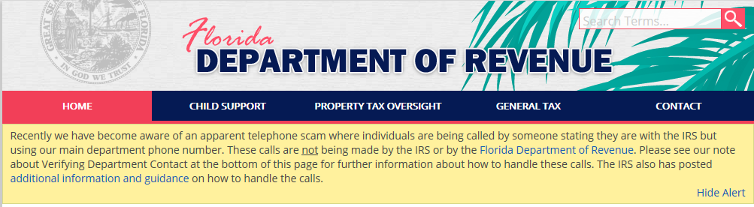

Figure - An Example of a "Global" alert box

To continue our discussion of what the Scope options mean:

EXE – displays the alert box on the main Florida Department of Revenue homepage.

GTA – displays the alert box on the General Tax Administration homepage.

CSE – displays the alert box on the Child Support Program homepage.

PTO – displays the alert box on the Property Tax Oversight homepage.

Again, all of these options can be used in conjunction with each other. If you want to place the alert box on all four major homepages on the Department of Revenue website, but don’t wish to utilize the “Global” style of alert, this is how the boxes should be checked:

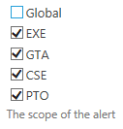

**Note**: It is important for the person adding or editing an alert to double-check with the Revenue Communications Office regarding which pages the alert box should be displayed on. In some prior alert box messages, the message was displayed on the main homepage and the General Tax Administration homepage, but not displayed on the CSE or PTO homepages.

After filling in all of the required form fields, press the Save button to store your alert box message. You are not done yet, as the new or edited message will be in Pending state until approved by a user with Approver permissions (Usually, this is a senior member of the ISP SharePoint team or someone in the Communications Office). **The alert box will not be shown to external visitors of Revenue’s website while the message is in the Pending state.**

If you are the person approving the message, here’s how to approve the alert and display it to external visitors to Revenue’s website.

Return to the Alerts list administration page.

Find the alert message you wish to approve. Look under the Approval Status column and you should see the message is in Pending state.

Click on the SharePoint ellipsis () next to the message you wish to change the approval status for.

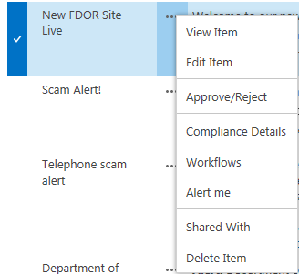

Click Approve / Reject from the pop-up menu. You will see the screen below.

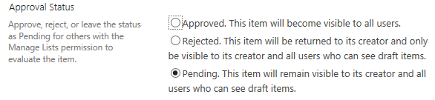

Select the radio button next to “Approved” to make the alert box visible to all external website users or to finalize scheduling of an alert message to be displayed in the future. It is important to remember that any time an alert message or one of its associated fields is edited, the alert’s approval status will be reset to “Pending.” Always re-visit the Approval screen after editing a message.

**Note**: The Rejected status is used to deactivate alert messages without deleting the message itself; in this way, the alert message can be re-used at a later date. The Communications Office may also choose to Reject any draft items which need to be revised or re-worked. For this reason, do not set a Rejected item back to Approved without first checking with the Communications Office.

## Deploying Single-Message and Multiple-Message Alert Boxes to a specific SharePoint page

Another variant of the alert box can be used to display an alert box on any SharePoint web page, not just the four main Revenue Internet homepages. This 2nd variant can be placed anywhere on a SharePoint page that has web part zones or a content editor set up. For convenience, we are going to refer to this type of alert box as the “Any-Page Alert Box.”

Here is an example of the “Any-Page Alert Box” that was set up on the Florida Department of Revenue’s Contact Us web page. It was placed to inform website visitors of an office closure. In such a situation, the main FDOR homepages may display a generic alert box message that points people to visit the Contact Us page for specific details. In this way, the alert box message only has to be edited in one place, while the generic office closure message on the program homepages can stay up without frequent edits.

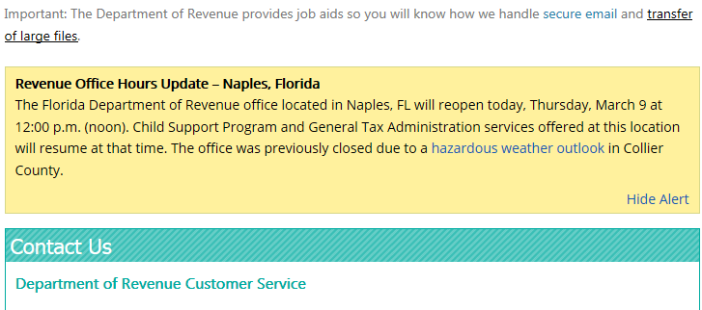

Figure - An example of the "Any-Page" Alert Box.

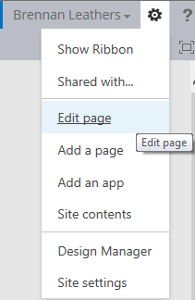Note that while the alert box looks very similar to the alert box that can be placed on program homepages, the steps for deploying the Any-Page Alert Box are different. To begin, browse to page you wish to place the alert on: (For example, <https://dorspint.fdor.dor.state.fl.us/Pages/contact.aspx>). Then click on the SharePoint “Cog” in the upper-right of the web browser screen, and in the menu that pops up, click “Edit Page.”

In the Edit Page view, you will see the SharePoint web page split up into Content Editor web parts. These web parts are used to place text, pictures, SharePoint lists and other content onto the page.

Step 2 is to place the mouse cursor where you wish to insert the alert box. For example, to insert the alert box before all other content on the page, place the cursor before the first Content Editor that currently exists on the page. On certain pages, it can be tricky to place the cursor before the first web part, or between web parts, so a trial-and-error process may need to be followed.

Step 3 is to click on the “Insert” tab in the SharePoint ribbon/toolbar. Then click on the (Insert) Web Part icon.

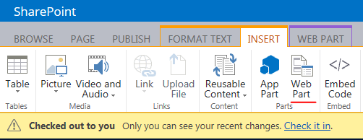

Next you will see a catalog of web parts that are available to insert onto a page, divided into categories that can contain multiple web parts. Click on the Alerts category and then choose the Single Alert Box (supports one alert message) or Multiple Alert Box (supports multiple messages).

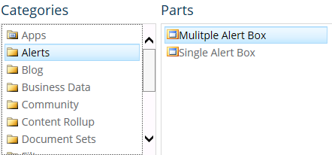

You will see a new Content Editor web part inserted onto the page. The web part initially appears to be blank, but contains the HTML and Javascript source code that makes the alert box function.



To continue click on the web part editing menu, which can be displayed by placing the mouse over the right-hand side of the content editor web part and clicking on the small, downward-facing arrow that appears.

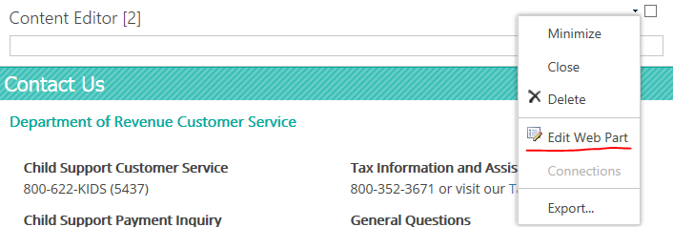

Next, click on “Edit Web Part.” This is the first step to editing the contents of the alert box.

The page will re-load and you will see the Content Editor’s web part properties menu display. We won’t need to modify the web part properties, but this lets us know we are working with the web part we just inserted.

Important: To edit the alert box source code, click the cursor focus within the blank whitespace under the Content Editor title.



Then click on the “Edit Source” icon in the SharePoint ribbon/toolbar.

You will see the HTML source editing window, which we will use to edit our alert. Don’t be alarmed, it is easier to edit the alert source code, even for users with basic HTML knowledge.

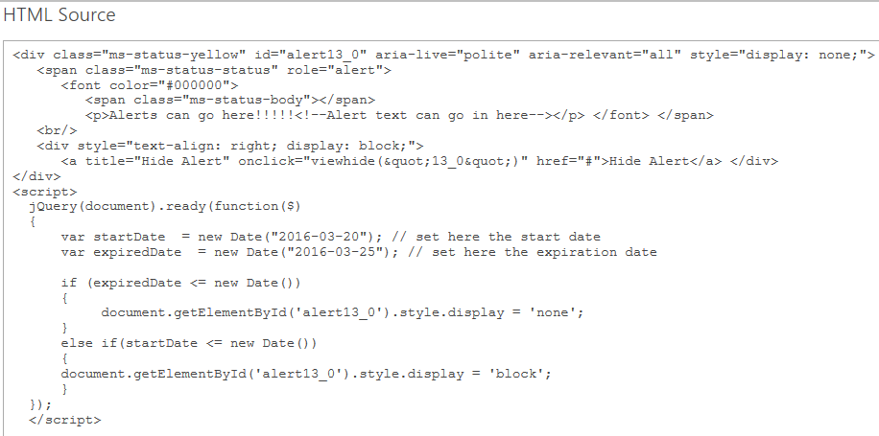

To edit the alert message’s text, look for the following line of source code:



Figure - A snippet of HTML code that can be edited to alter the alert box message.

The <p> is an HTML tag that indicates the start of a paragraph, while the </p> is an HTML tag that indicates the end of a paragraph. Most alert messages are only one paragraph in length, but for example’s sake, we will create an alert message with two paragraphs.

The existing text that says “Alerts can go here!!” is placeholder text, and the code that appears as <!—Alert text can go in here--> is an HTML comment that is not displayed to website visitors.

For our example, we will create an alert box with a holiday office closure message. Replace the text in figure 4 with the following code:

<p><b>Attention:</b> All Florida Department of Revenue offices will be closed on December 25. The offices will re-open on December 27.</p>  
<p>In addition, Department of Revenue offices will also be closed on December 31 and New Year’s Day. The offices will re-open on January 2.</p>

Next, find the code that looks like this:



Figure - A snippet of HTML code that can be edited to alter date and times during which the alert box will be displayed.

The first line of the code in Figure 5 determines the Start Date for the alert box. The only part of the code that should be edited is the date within the quotes, and the date you wish to specify should follow the same format, YYYY-MM-DD.

The second line determines the End Date for the alert box, and the same instructions apply as for the Start Date. If the End Date is in the past, the alert box will not be displayed—not in Edit Page mode, and not to the end user.

Edit the code so that it looks like this:



Then click OK in the bottom right of the Edit HTML source screen. At first, the alert box will not display. In the Content Editor web part properties window on the right, press the “Apply” button.

The page will re-load and the alert box will display (Note: the alert box will not display if the Start Date is in the future, or the End Date is in the past).

Next, Check In the web page.



The alert box we just added still won’t display until we publish the page. Click “Publish this draft” to publish the page and make it visible to all users.



Our alert box is now possible, assuming the Start Date and End Date display conditions are met.

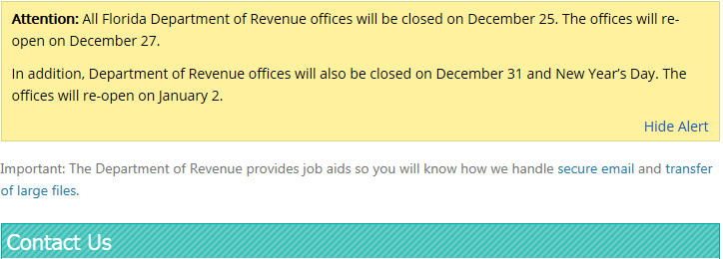

You can add links to the Any-Page Alert box using the following HTML code:

<a href=http://floridarevenue.com>Florida Department of Revenue</a> homepage

This will display a link like the following: [Florida Department of Revenue](http://floridarevenue.com/) homepage

An aside note about the alert boxes: all of the alert boxes can be “hidden” by the end user. This is done by clicking on the “Hide Alert” link in the bottom-right of the alert box.

For the “Any-Page” alert box, hiding the alert only lasts on the current view of the web page; if the web page is reloaded, the alert box will be re-displayed.

For the alert box that is displayed on program homepages, clicking on “Hide Alert” will hide the alert box, except for a link that says “Show Alert,” which allows the user to re-display the alert if desired. For this type of alert boxes, the user’s choice to “hide” the alert box will persist across multiple user visits, until a new alert is added or the user chooses to show the alert box again.